Kindergarten Notes
(please save for reference)
Mrs. Colling

Arrival and Dismissal
Kindergarten students line up at the kindergarten doors and I will lead the students inside at 8:10 a.m. If your child is tardy, please check-in at the main office.
The children will be dismissed one at a time from the same door at 3:24 p.m. Your child will only be released to you or the people you designate on the emergency card. For the safety of your child, any changes must be in writing. In the event that you are late picking up your child, I will take him or her to the main office.
Early Release Days-1:54 p.m dismissal Half-Days -11:25 a.m dismissal
**Please note, the first week of school for kindergarteners are half-days.**

Notes
Notes are required for the following reasons:
· Advanced notice of planned absences (notify office also).
· Early dismissal for appointments.
· When someone “new” will be picking your child up from school, this includes going home with a school friend.

Home/School Communication
Each day your child should bring home his or her purple folder. Please remove the completed work and/or parent information, and return the folder the following day. I will check the folder each day for important notes from you, lunch money, completed homework, etc. It is very important that we keep this organizational system in place throughout the year. You may also contact me by leaving a message on the classroom phone, (586) 285-8721 or e-mail ccolling@lsps.org. I will try to return these messages within 24 hours during the school week. For urgent messages please contact the office at (586) 285-8700.
Snack
We will have a short snack break daily. Please send a healthy snack for your child each day. Snacks should be clearly labeled with your child’s name and sent separate from your child’s lunch. Drinks are unnecessary as we have a drinking fountain in the classroom. Small cups will be provided for the children to keep germs to a minimum. Snack suggestions include; dry cereal, granola, crackers, Goldfish, pretzels, cheese sticks, apples, bananas, and raisins. Due to allergies, children will not be allowed to share their snacks.

Lunch/Recess
The kindergarteners will have recess at 11:30 a.m. each day. Recess is usually held outdoors so please be sure to dress your child for the weather. The children will come in to eat lunch following recess. You may pack a cold lunch or buy hot lunch for your child. When sending lunch money, please place it in an envelope that is labeled with your child’s name. Many families choose to send in enough money for several lunches at a time. Extra money will be placed in your child’s lunch account for future use. Please see the lunch menu for current charges.

Dressing for School
Please see the school dress code in the student handbook for specific details, but in general, students should dress in comfortable clothing that is appropriate for the weather. For safety reasons, please do not send your child to school in flip flops or open-toed shoes. Also, you may want to send a complete change of clothes in a plastic bag, labeled with your child’s name. This will be stored in your child locker and used in the event of a bathroom “accident,” spills, etc.

We ask that students wear their Violet All-Star shirts for field trips and special all-school events such as Field Day.

Positive Behavior Support
Lake Shore Public Schools is committed to encouraging your child toward responsible citizenship. Therefore, each student is expected to abide by the following Lifelong Guidelines:
- Active Listening
- Personal Best
- Truthfulness
- Trustworthiness
- No Put Downs
Positive behavior that follows these guidelines will be rewarded with praise, special notes home, and various child-friendly tokens (stickers, prizes, extra responsibilities around the classroom, etc.). In kindergarten, most inappropriate behaviors can be handled through discussion and redirection. I’ll be using a program called Class Dojo to communicate with you regarding your child’s positive and/or negative behaviors. Please look for a separate note regarding Class Dojo.
Violet School also has a STAR reward program. Students can earn this award by exhibiting behavior that is Safe, Trustworthy, And Respectful.

Child of the Day
Everyday a student in the class is offered a chance to be the “Child of the Day.” This classroom helper will assist the teacher with our morning calendar routine, be the line-leader, and perform other classroom jobs. Every child will get several turns as the “Child of the Day” throughout the school year. This special routine helps the children develop the lifeskills of responsibility and patience.

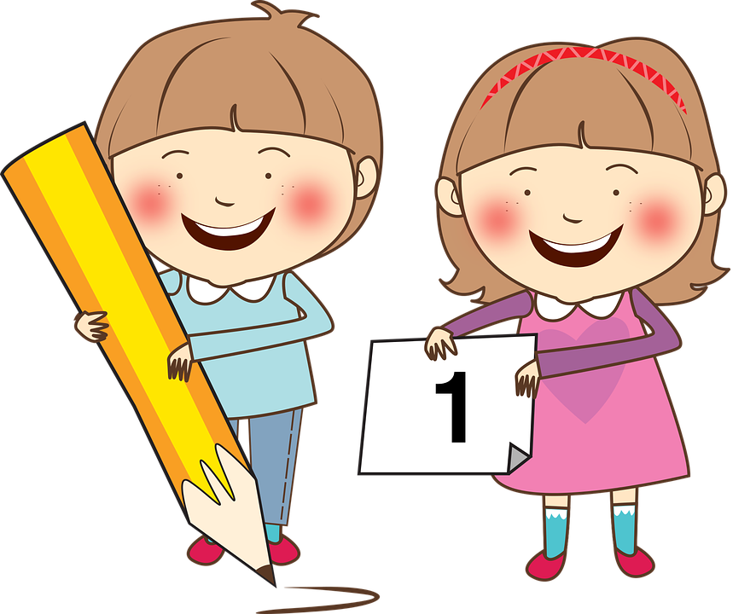Homework
Kindergarten homework consists of discussing the school day with an adult, completing 3 activities from the “Homework Calendar,” and daily reading. Pencil and paper homework will be sent home as the year progresses. In addition, special projects may be assigned periodically throughout the year. Unfinished classwork may be marked with an “HW” for homework, and should be completed and returned the following school day.

Conferences
Formal conferences with your child’s teacher are held two times during the school year (late fall and spring). These conferences are planned to discuss your child’s progress. Feel free to contact your child’s teacher anytime you have a question or concern.

Grading
Much of our work in kindergarten is completed as a group so formal grading does not apply. Work that I have checked will usually have a star or a sticker on it. Areas in which extra practice is needed will be highlighted, circled, or contain the word “practice.” Excellent work may be marked with a “PB,” indicating “Personal Best.”

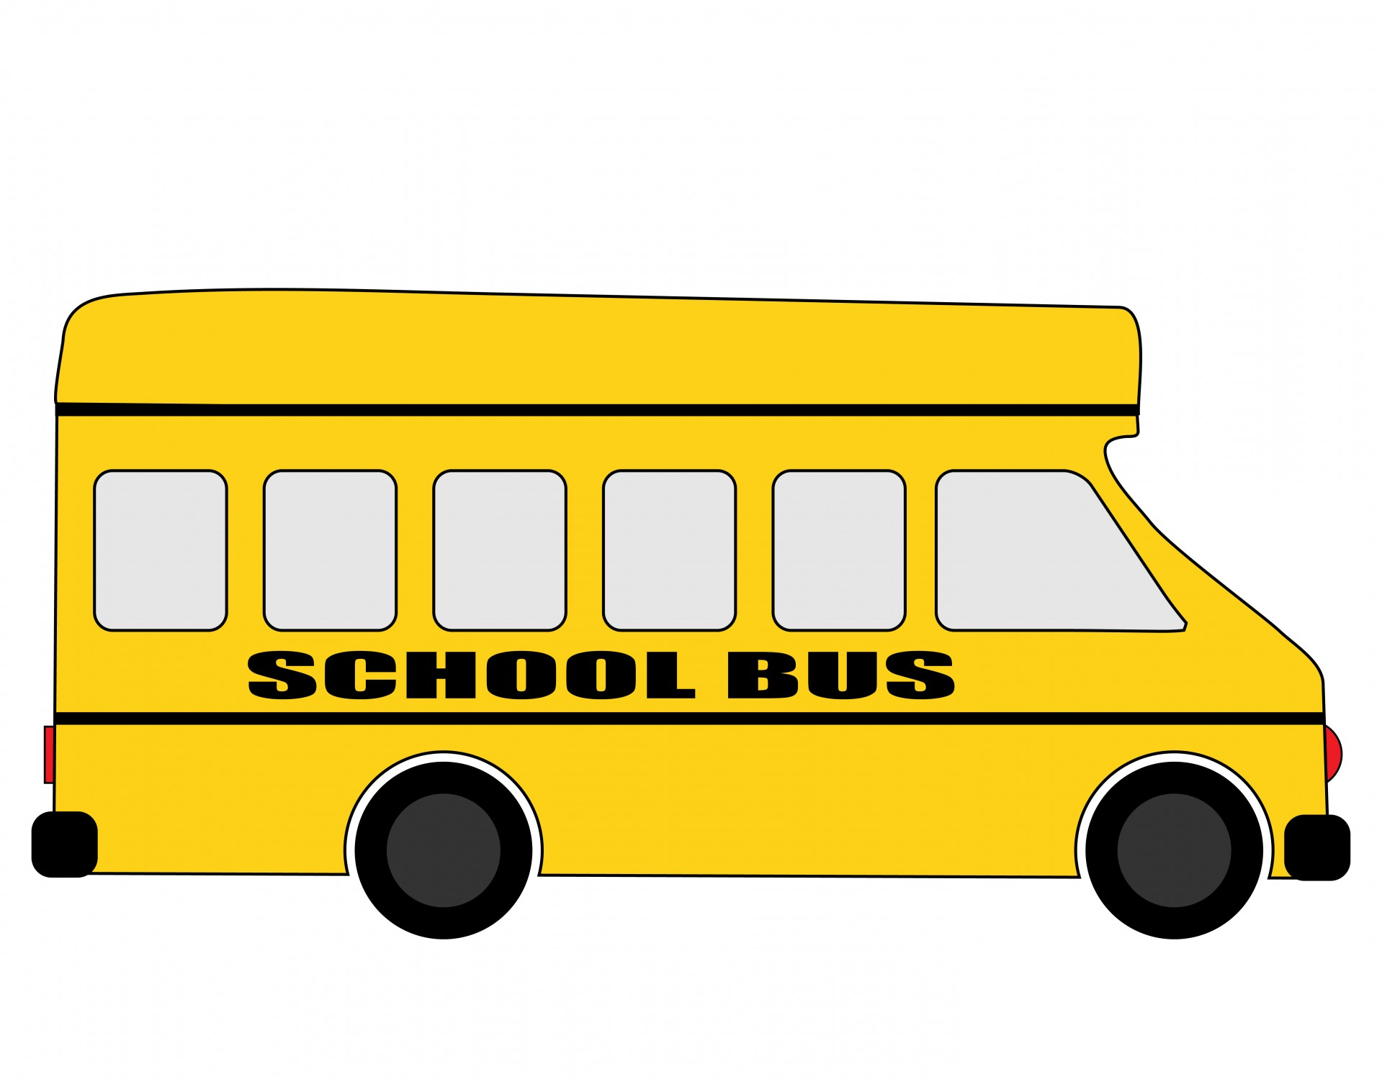Field Trips/Volunteers
Three trips are tentatively planned for the kindergarten classes. You will be notified of dates and specifics as soon as the information becomes available. If you would like to chaperone one of these events, you must have a cleared background check on file with the office.

School Supplies
If you would like to donate something to our class we could always use Kleenex, Clorox Wipes, Dixie Cups, napkins, Ziploc baggies of all sizes, envelopes, and plastic spoons or forks.

Birthdays
Due to an increase in food allergies, we are asking that you do not send cupcakes to celebrate your child’s birthday. If you want to send something, feel free to send any non-food item to celebrate this special day. Suggestions include special pencils or a copy of your child’s favorite book. Your child will receive a paper birthday crown from me and a birthday ribbon from the office. The week of your child’s birthday, he/she will be invited to VTV so the whole school can sing “Happy Birthday!” Summer birthdays are also included during the last few weeks of school.

